**Um documento denominado resposta.doc com as**

**queries e as respostas das questões propostas.**

**- Quantos registros há na tabela por ano?**

**Tabela de Partidas:**

SELECT

count(*) AS Qtd_Registros

,Ano

FROM PARTIDAS_GERAL

GROUP BY Ano

ORDER BY Ano ASC

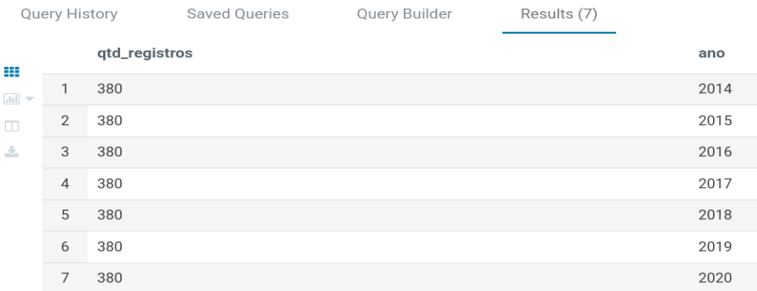

**Tabela de Scouts:**

SELECT

count(*) AS Qtd_Registros

,Ano

from scouts_geral

GROUP BY Ano

ORDER BY Ano Asc

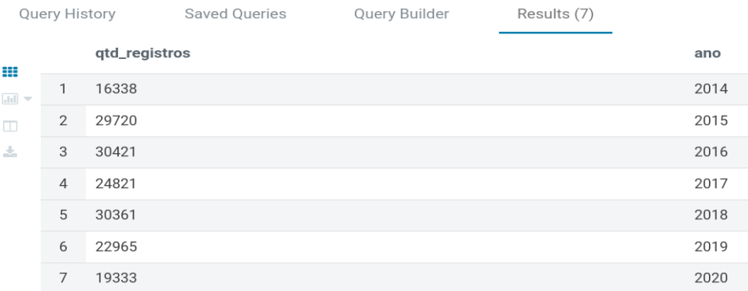

**Total da tabela Partida e Scouts:**

WITH CTE AS(

SELECT COUNT(*) as QTD_REGISTROS,'Partidas' as Tabela FROM PARTIDAS_GERAL

), CTE2 AS (

SELECT count(*) AS QTD_REGISTROS,'Scouts' as Tabela from scouts_geral

)

SELECT * FROM CTE

UNION

SELECT * FROM CTE2

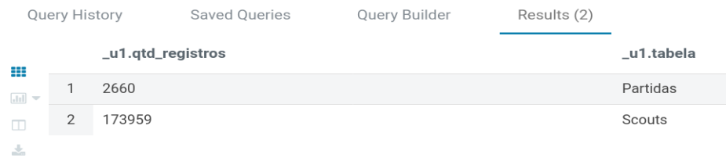

**- Quantas equipes únicas mandantes existem?**

Select

count(distinct Casa) Qtde_Equipes_Unicas_Mandantes

,Ano

FROM PARTIDAS_GERAL

GROUP BY Ano

ORDER BY Ano ASC

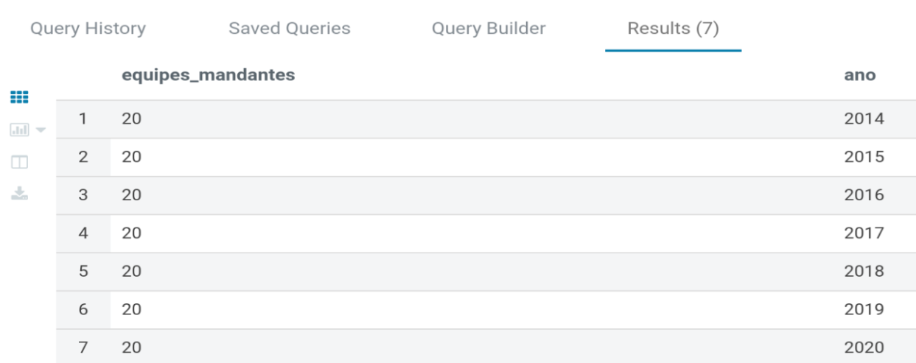

**- Quantas vezes as equipes mandantes saíram vitoriosas?**

Select

count(*) as Qtde_Vitorias_Mandantes

,Ano

FROM PARTIDAS_GERAL

WHERE Resultado = 'Casa'

GROUP BY Ano

ORDER BY Ano

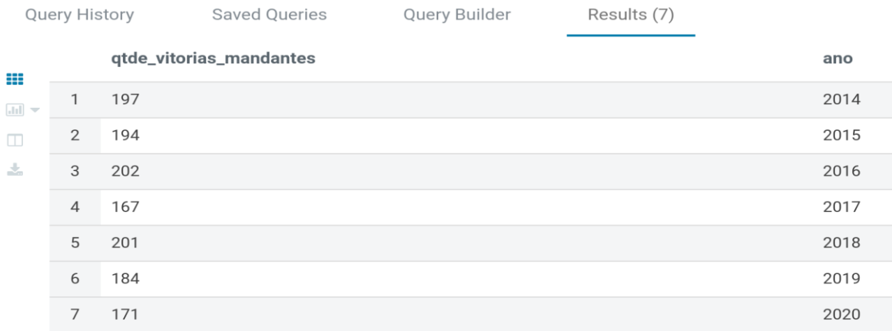

**- Quantas vezes as equipes visitantes saíram vitoriosas?**

SELECT

count(*) as Qtde_Vitorias_Visitante

,Ano

FROM PARTIDAS_GERAL

WHERE Resultado = 'Visitante'

GROUP BY Ano

ORDER BY Ano

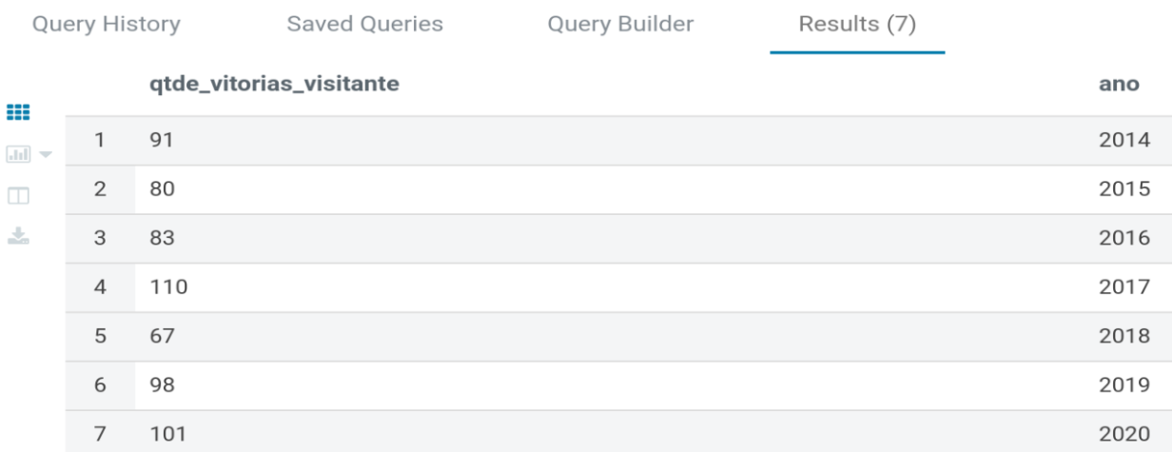

**- Quantas partidas resultaram em empate?**

SELECT

count(*) as Qtde_Empates

,Ano

FROM PARTIDAS_GERAL

WHERE Resultado = 'Empate'

GROUP BY Ano

ORDER BY Ano

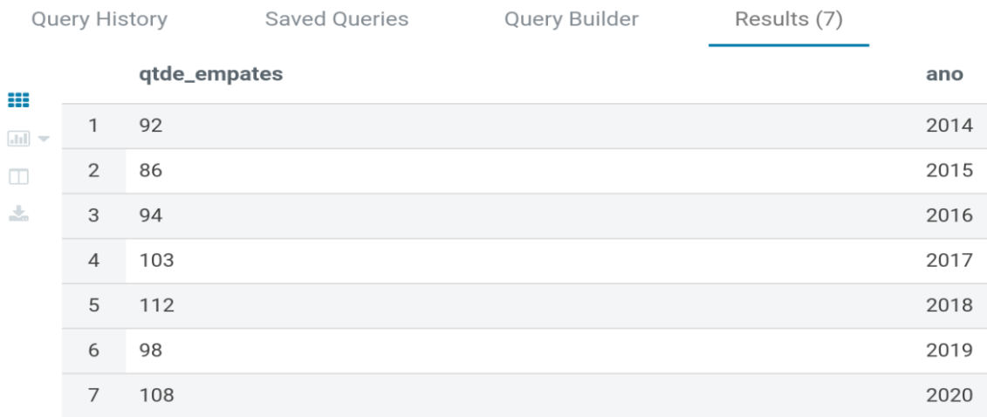

**- Quais jogadores detêm os melhores scouts gerais e por ano?**

**Scouts Gerais:**

WITH cte as (

SELECT

ROW_NUMBER() OVER (partition by Ano ORDER BY sum(Pontos) desc,Ano desc) as colocacao

,round(sum(Pontos),2) as total_pontos

,Atleta

,Clube,Ano

FROM scouts_geral

GROUP BY Atleta ,Clube,Ano

)

SELECT * FROM cte WHERE colocacao = 1 ORDER BY total_pontos DESC

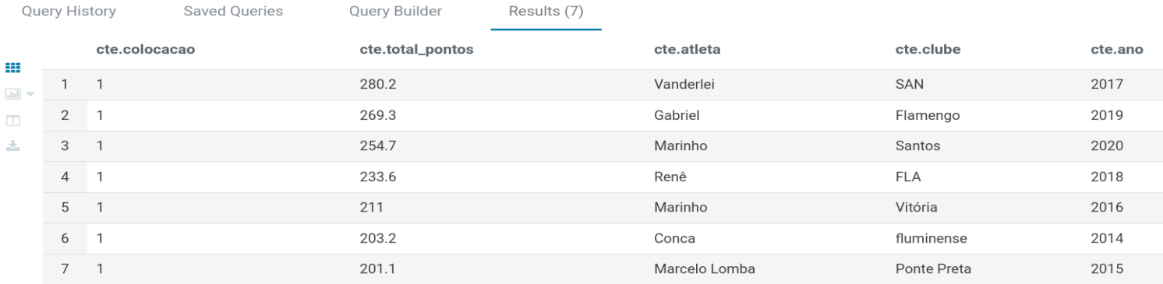

**Melhores scouts de 2014:**

SELECT

ROW_NUMBER() OVER (partition by Ano ORDER BY sum(Pontos) desc,Ano desc) as colocacao

,round(sum(Pontos),2) as total_pontos

,Atleta

,Clube,Ano

FROM scouts_geral

WHERE Ano = 2014

GROUP BY Atleta ,Clube,Ano

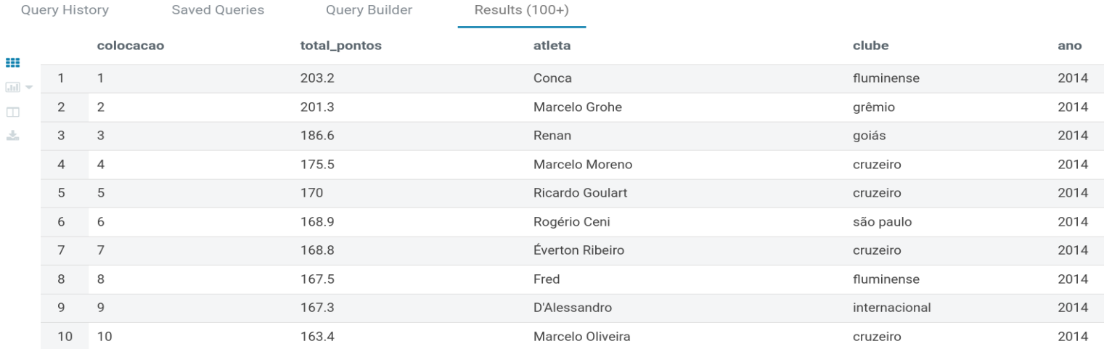

**Melhores scouts de 2015:**

SELECT

ROW_NUMBER() OVER (partition by Ano ORDER BY sum(Pontos) desc,Ano desc) as colocacao

,round(sum(Pontos),2) as total_pontos

,Atleta

,Clube,Ano

FROM scouts_geral

WHERE Ano = 2015

GROUP BY Atleta ,Clube,Ano

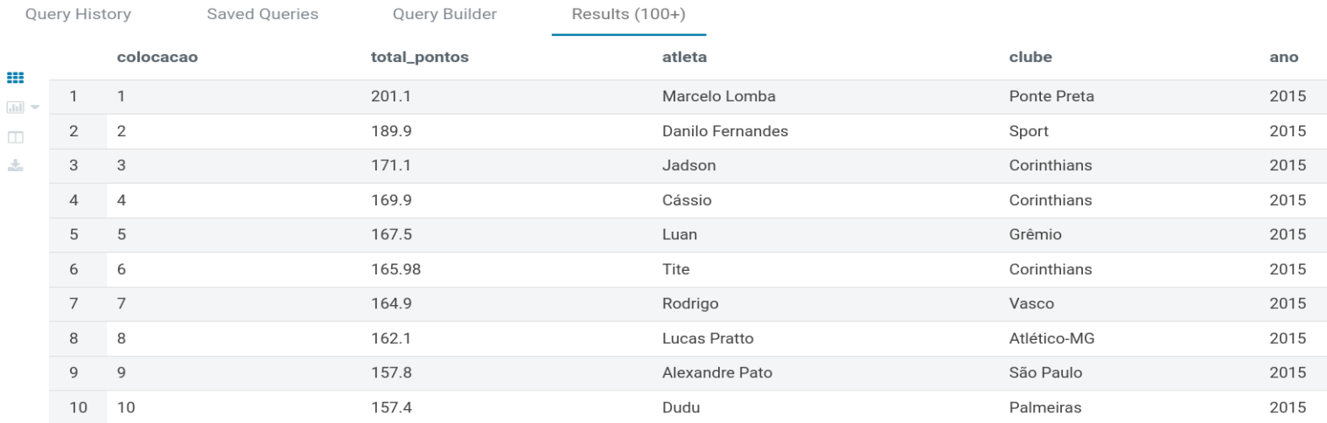

**Melhores scouts de 2016:**

SELECT

ROW_NUMBER() OVER (partition by Ano ORDER BY sum(Pontos) desc,Ano desc) as colocacao

,round(sum(Pontos),2) as total_pontos

,Atleta

,Clube,Ano

FROM scouts_geral

WHERE Ano = 2016

GROUP BY Atleta ,Clube,Ano

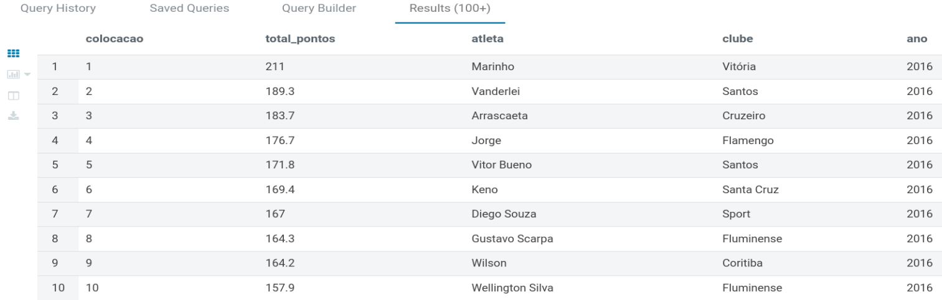

**Melhores scouts de 2017:**

SELECT

ROW_NUMBER() OVER (partition by Ano ORDER BY sum(Pontos) desc,Ano desc) as colocacao

,round(sum(Pontos),2) as total_pontos

,Atleta

,Clube,Ano

FROM scouts_geral

WHERE Ano = 2017

GROUP BY Atleta ,Clube,Ano

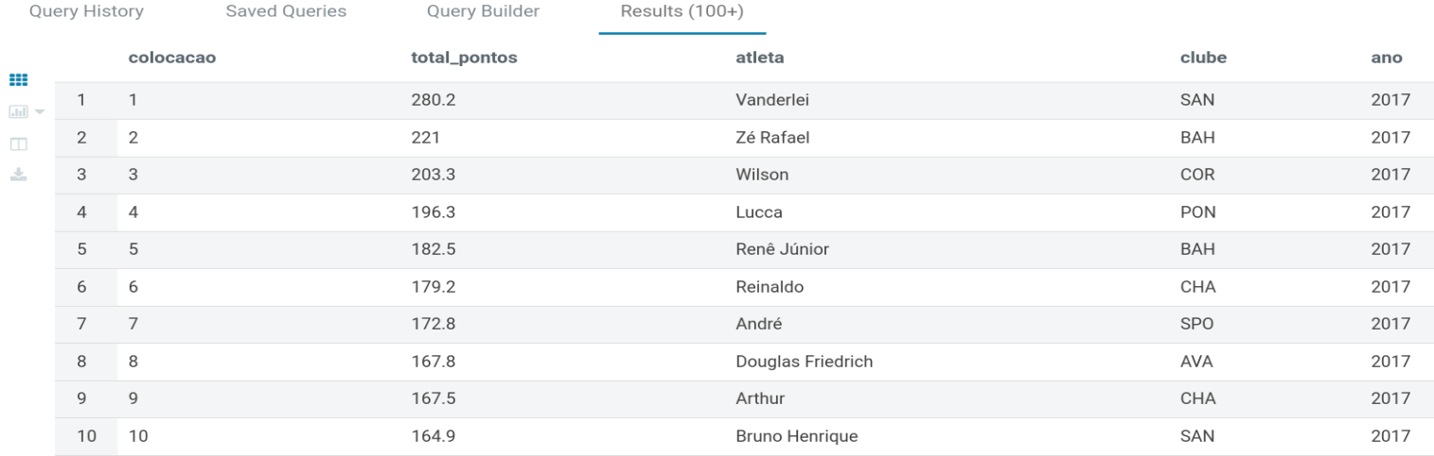

**Melhores scouts de 2018:**

SELECT

ROW_NUMBER() OVER (partition by Ano ORDER BY sum(Pontos) desc,Ano desc) as colocacao

,round(sum(Pontos),2) as total_pontos

,Atleta

,Clube,Ano

FROM scouts_geral

WHERE Ano = 2018

GROUP BY Atleta ,Clube,Ano

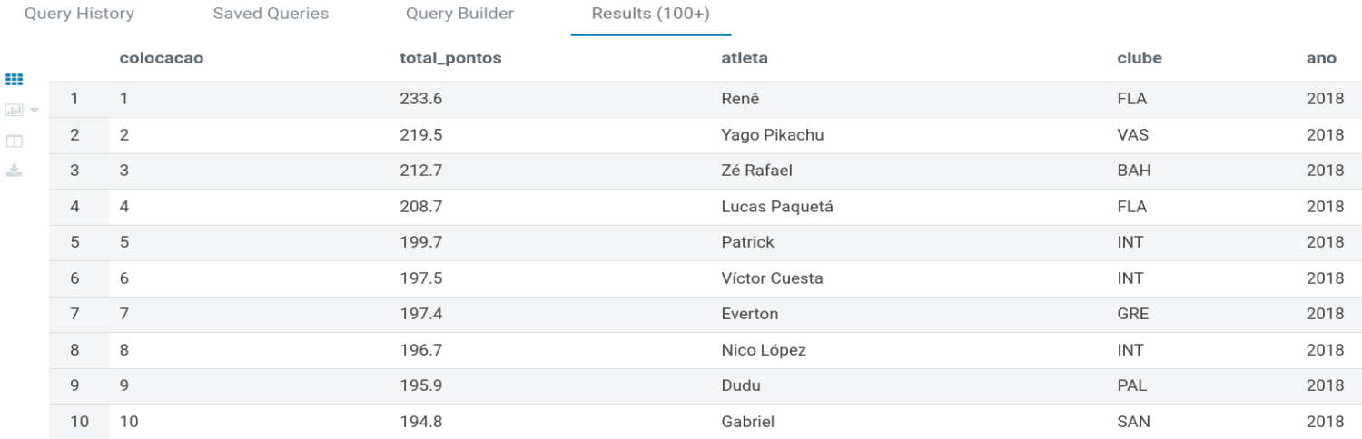

**Melhores scouts de 2019:**

SELECT

ROW_NUMBER() OVER (partition by Ano ORDER BY sum(Pontos) desc,Ano desc) as colocacao

,round(sum(Pontos),2) as total_pontos

,Atleta

,Clube,Ano

FROM scouts_geral

WHERE Ano = 2019

GROUP BY Atleta ,Clube,Ano

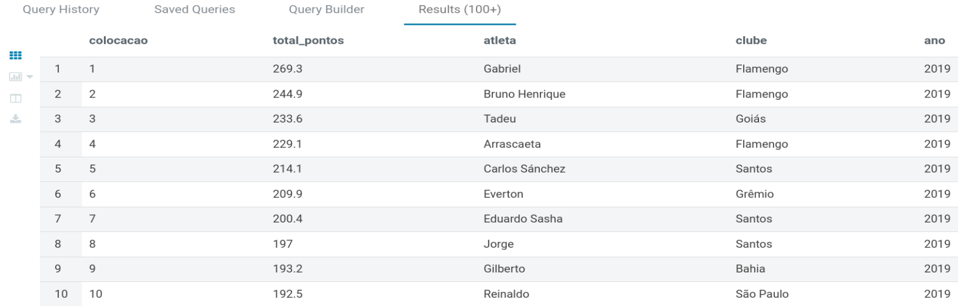

**Melhores scouts de 2020:**

SELECT

ROW_NUMBER() OVER (partition by Ano ORDER BY sum(Pontos) desc,Ano desc) as colocacao

,round(sum(Pontos),2) as total_pontos

,Atleta

,Clube,Ano

FROM scouts_geral

WHERE Ano = 2020

GROUP BY Atleta ,Clube,Ano

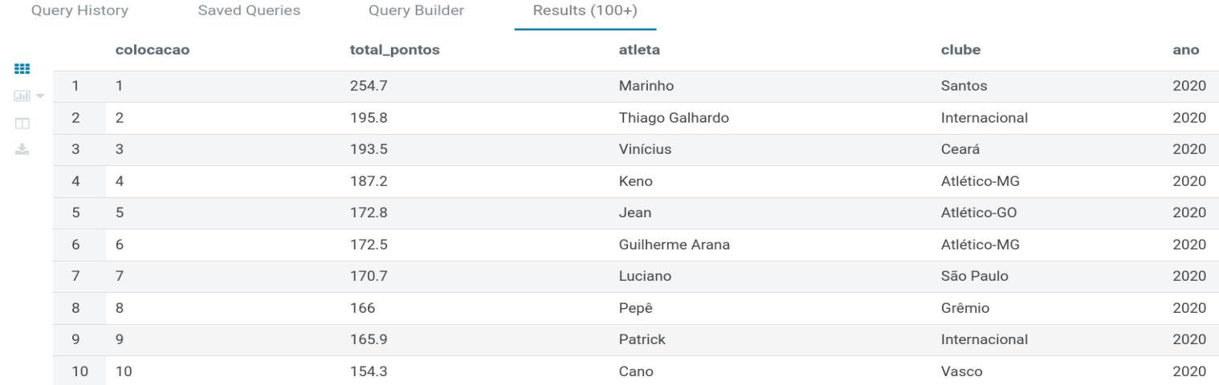

**- Qual é o time ideal?**

**Time ideal de 2014:**

WITH cte AS (

SELECT ROW_NUMBER() OVER (PARTITION BY Posicao,Ano ORDER BY avg(Pontos) DESC,Ano DESC) AS colocacao

,round(avg(Pontos),2) AS total_pontos

,Atleta

,Clube

,Posicao

,Ano

FROM scouts_geral

WHERE Ano = 2014

GROUP BY Atleta ,Clube,Posicao,Ano)

SELECT * FROM cte

WHERE

(colocacao = 1 AND posicao LIKE 'Gol%')

OR (colocacao IN (1,2) AND posicao LIKE 'Lat%')

OR (colocacao IN (1,2) AND posicao LIKE 'Zag%')

OR (colocacao IN(1,2,3) AND posicao LIKE 'Mei%')

OR (colocacao IN (1,2,3) AND posicao LIKE 'Ata%')

OR (colocacao IN (1) AND posicao LIKE 'Téc%')

ORDER BY colocacao ASC

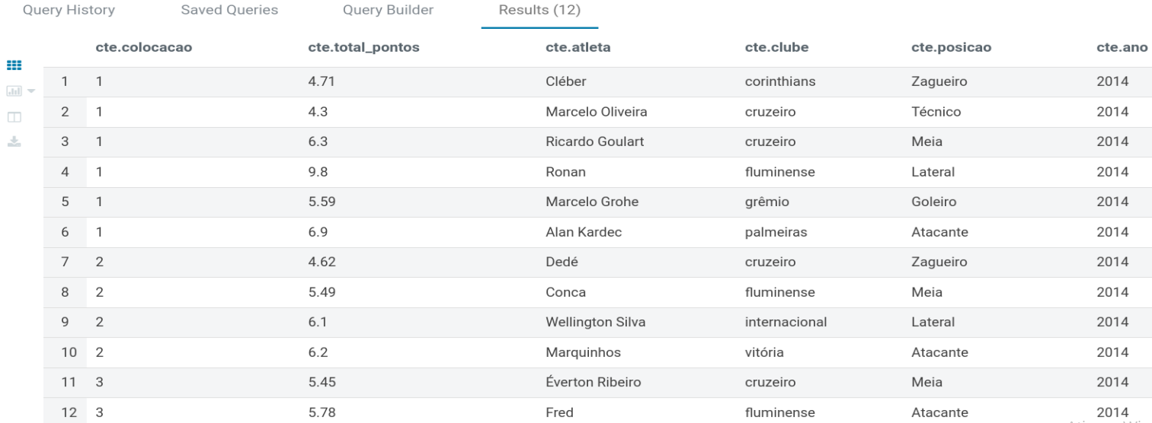

**Time ideal de 2015:**

WITH cte AS (

SELECT ROW_NUMBER() OVER (PARTITION BY Posicao,Ano ORDER BY avg(Pontos) DESC,Ano DESC) AS colocacao

,round(avg(Pontos),2) AS total_pontos

,Atleta

,Clube

,Posicao

,Ano

FROM scouts_geral

WHERE Ano = 2015

GROUP BY Atleta ,Clube,Posicao,Ano)

SELECT * FROM cte

WHERE

(colocacao = 1 AND posicao LIKE 'Gol%')

OR (colocacao IN (1,2) AND posicao LIKE 'Lat%')

OR (colocacao IN (1,2) AND posicao LIKE 'Zag%')

OR (colocacao IN(1,2,3) AND posicao LIKE 'Mei%')

OR (colocacao IN (1,2,3) AND posicao LIKE 'Ata%')

OR (colocacao IN (1) AND posicao LIKE 'Téc%')

ORDER BY colocacao ASC

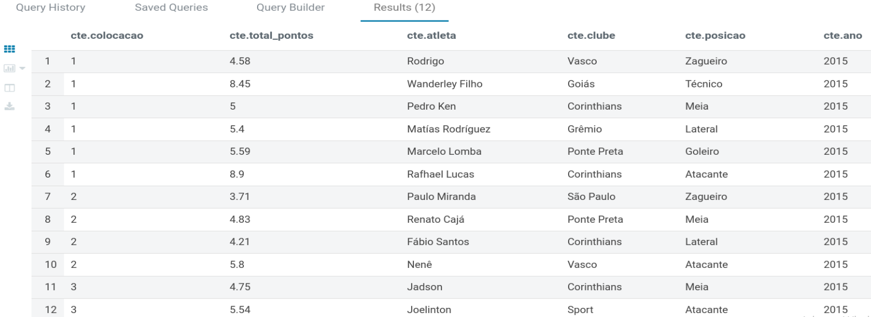

**Time ideal de 2016:**

WITH cte AS (

SELECT ROW_NUMBER() OVER (PARTITION BY Posicao,Ano ORDER BY avg(Pontos) DESC,Ano DESC) AS colocacao

,round(avg(Pontos),2) AS total_pontos

,Atleta

,Clube

,Posicao

,Ano

FROM scouts_geral

WHERE Ano = 2016

GROUP BY Atleta ,Clube,Posicao,Ano)

SELECT * FROM cte

WHERE

(colocacao = 1 AND posicao LIKE 'Gol%')

OR (colocacao IN (1,2) AND posicao LIKE 'Lat%')

OR (colocacao IN (1,2) AND posicao LIKE 'Zag%')

OR (colocacao IN(1,2,3) AND posicao LIKE 'Mei%')

OR (colocacao IN (1,2,3) AND posicao LIKE 'Ata%')

OR (colocacao IN (1) AND posicao LIKE 'Téc%')

ORDER BY colocacao ASC

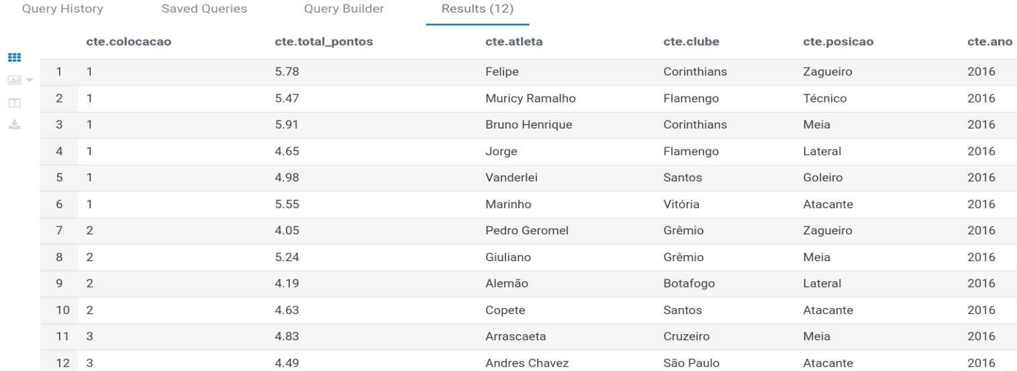

**Time ideal de 2017:**

WITH cte AS (

SELECT ROW_NUMBER() OVER (PARTITION BY Posicao,Ano ORDER BY avg(Pontos) DESC,Ano DESC) AS colocacao

,round(avg(Pontos),2) AS total_pontos

,Atleta

,Clube

,Posicao

,Ano

FROM scouts_geral

WHERE Ano = 2017

GROUP BY Atleta ,Clube,Posicao,Ano)

SELECT * FROM cte

WHERE

(colocacao = 1 AND posicao LIKE 'gol%')

OR (colocacao IN (1,2) AND posicao LIKE 'lat%')

OR (colocacao IN (1,2) AND posicao LIKE 'zag%')

OR (colocacao IN(1,2,3) AND posicao LIKE 'mei%')

OR (colocacao IN (1,2,3) AND posicao LIKE 'ata%')

OR (colocacao IN (1) AND posicao LIKE 'tec%')

ORDER BY colocacao ASC

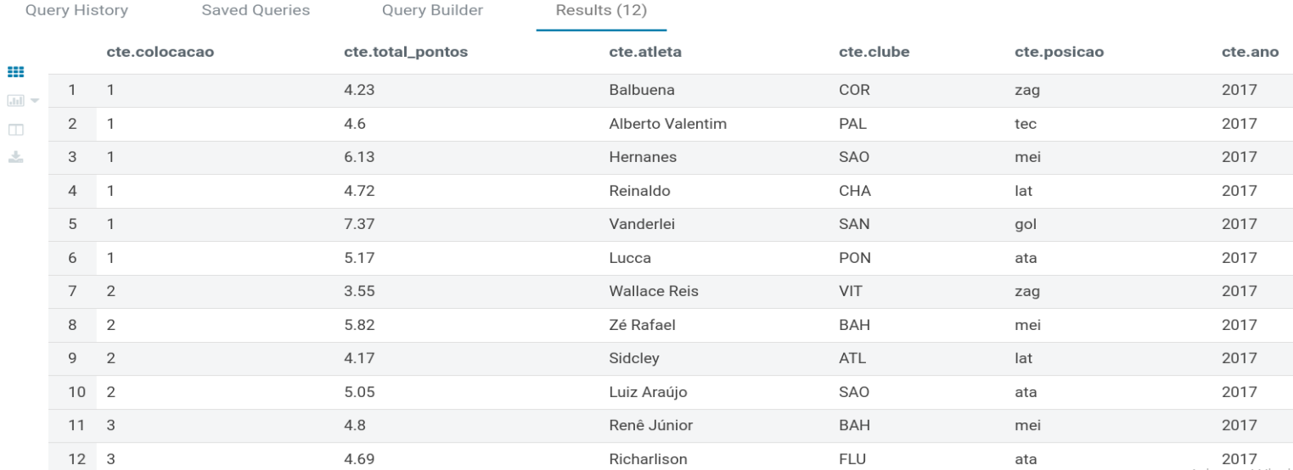

**Time ideal de 2018:**

WITH cte AS (

SELECT ROW_NUMBER() OVER (PARTITION BY Posicao,Ano ORDER BY avg(Pontos) DESC,Ano DESC) AS colocacao

,round(avg(Pontos),2) AS total_pontos

,Atleta

,Clube

,Posicao

,Ano

FROM scouts_geral

WHERE Ano = 2018

GROUP BY Atleta ,Clube,Posicao,Ano)

SELECT * FROM cte

WHERE

(colocacao = 1 AND posicao LIKE 'gol%')

OR (colocacao IN (1,2) AND posicao LIKE 'lat%')

OR (colocacao IN (1,2) AND posicao LIKE 'zag%')

OR (colocacao IN(1,2,3) AND posicao LIKE 'mei%')

OR (colocacao IN (1,2,3) AND posicao LIKE 'ata%')

OR (colocacao IN (1) AND posicao LIKE 'tec%')

ORDER BY colocacao ASC

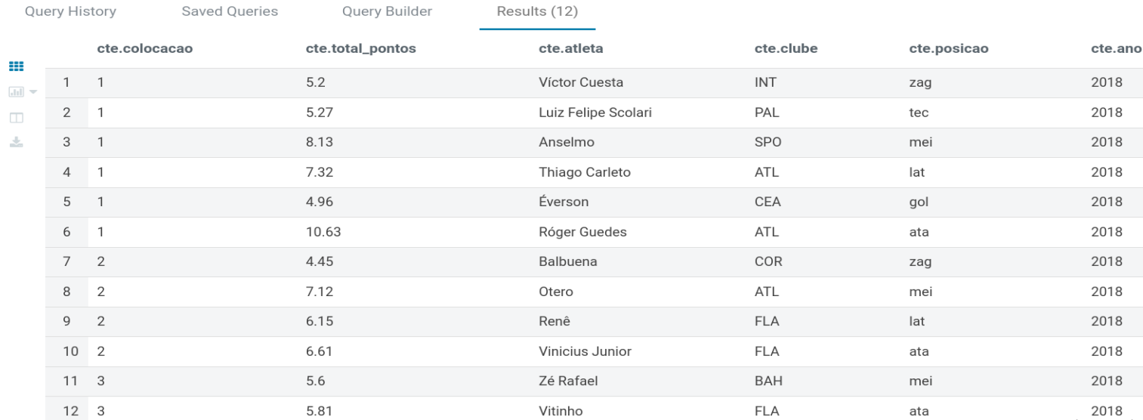

**Time ideal de 2019:**

WITH cte AS (

SELECT ROW_NUMBER() OVER (PARTITION BY Posicao,Ano ORDER BY avg(Pontos) DESC,Ano DESC) AS colocacao

,round(avg(Pontos),2) AS total_pontos

,Atleta

,Clube

,Posicao

,Ano

FROM scouts_geral

WHERE Ano = 2019

GROUP BY Atleta ,Clube,Posicao,Ano)

SELECT * FROM cte

WHERE

(colocacao = 1 AND posicao LIKE 'gol%')

OR (colocacao IN (1,2) AND posicao LIKE 'lat%')

OR (colocacao IN (1,2) AND posicao LIKE 'zag%')

OR (colocacao IN(1,2,3) AND posicao LIKE 'mei%')

OR (colocacao IN (1,2,3) AND posicao LIKE 'ata%')

OR (colocacao IN (1) AND posicao LIKE 'tec%')

ORDER BY colocacao ASC

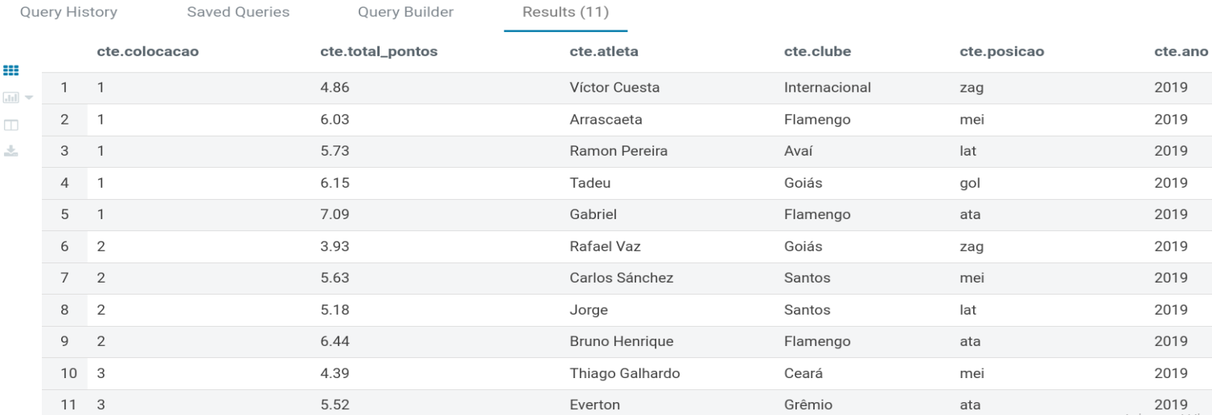

**Time ideal de 2020:**

WITH cte AS (

SELECT ROW_NUMBER() OVER (PARTITION BY Posicao,Ano ORDER BY avg(Pontos) DESC,Ano DESC) AS colocacao

,round(avg(Pontos),2) AS total_pontos

,Atleta

,Clube

,Posicao

,Ano

FROM scouts_geral

WHERE Ano = 2020

GROUP BY Atleta ,Clube,Posicao,Ano)

SELECT * FROM cte

WHERE

(colocacao = 1 AND posicao LIKE 'gol%')

OR (colocacao IN (1,2) AND posicao LIKE 'lat%')

OR (colocacao IN (1,2) AND posicao LIKE 'zag%')

OR (colocacao IN(1,2,3) AND posicao LIKE 'mei%')

OR (colocacao IN (1,2,3) AND posicao LIKE 'ata%')

OR (colocacao IN (1) AND posicao LIKE 'tec%')

ORDER BY colocacao ASC

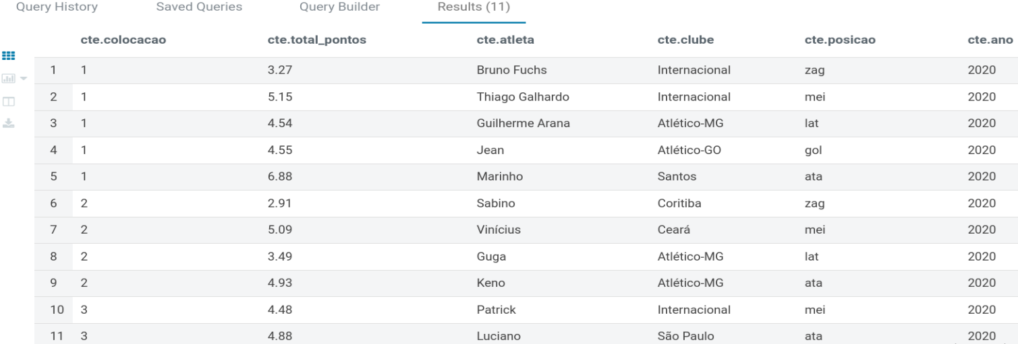

**- Será que podemos preparar a ingestão para o campeonato de 2021?**

Sim, a nossa solução está preparada para receber os dados de 2021 pois a nossa a forma de tratar, armazenar e disponibilizar esses dados em arquivos gerais na camada Manage suporta facilmente a entrada de um novo ano e facilita análises comparativas dos anos.

**- Como capturar os dados direto do Cartola FC?**

Podemos capturar acessando a API do Cartola FC, mas devido há um problema nesse serviço atualmente estamos capturando os dados do repositório do Git.